Outline of New Immigration Procedures: Requirements for the Provision of Personal Information
October 2007
Immigration Bureau, Ministry of Justice
1. General Outline
On 24th May 2006, a new law amending parts of the Immigration Control and Refugee Recognition Act was promulgated and is due to enter into force as of November 20
, 2007.
The revised law contains new provisions for the establishment of a framework for preventative measures against acts of terrorism. As part of this framework, a new anti-terrorism measure is to be implemented, which requires the submission of personal identification information at immigration control.
Under the new immigration procedures, when foreign nationals are applying for landing, fingerprints and a facial photograph will be taken after which an immigration control officer shall conduct an examination for landing.
In the event of any foreign national, who is required by the new law to be fingerprinted and photographed, refusing to submit to these new provisions, that person will not be permitted to enter Japan, and will be required to leave the country.
2. Affected persons
All foreign nationals entering Japan will be subject to the new provisions, apart from the following:
(1) Special permanent residents
(2) Persons under 16 years of age
(3) Those persons performing activities which fall under the status of residence for ‘Diplomat’ or ‘Official’
(4) Those persons who have been invited by the head of any national administrative organization
(5) Those persons who are prescribed by the Ministry of Justice ordinance as equivalent to either (3) or (4)
3. New Immigration Procedures
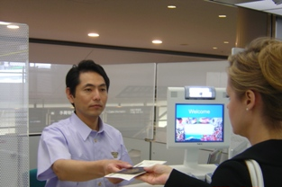
Applicants will be required to follow the following procedures.
- A person wishing to enter Japan must submit his/her passport to
the immigration control officer.

② Once the immigration control officer has explained the procedures that are to be followed, the person wishing to enter Japan will be asked to place the index fingers of both hands on a digital fingerprint reader. The fingerprint information will be read and stored electromagnetically.

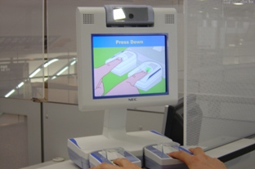
③ A facial photograph will then be taken, using the camera located at
the top of the digital fingerprint reader.

④ The immigration control officer will then conduct a short interview.

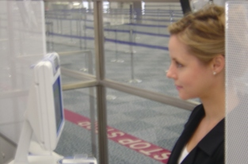
⑤ On completion of the above procedures, the person wishing to enter Japan will receive his/her passport from the immigration control officer.

Q&A
Why is the new immigration control system starting?
Answering your questions about the new immigration procedures.

Q. Why do I need to be fingerprinted and photographed at immigration control?
A. By collecting personally identifying data, such as fingerprints and facial photos, of visitors to Japan, we will be able to identify persons considered to pose security risks, such as terrorists, and persons traveling with passports that are not their own. This will help us to prevent terrorist attacks.
Q. What if I am not able to provide a fingerprint from my index finger?

A. If you are not able to provide a fingerprint from your index finger because, for example, that finger is missing from your hand, then you will be required to provide a fingerprint from another finger, according to an order drawn up by the Ministry of Justice. Please inform your immigration control officer of any such difficulties.
Q. What will happen if I do not provide fingerprints or a facial photograph?
A. Your immigration control officer will carefully examine your case, to determine whether or not you fall into one of the exempt categories. If, despite it having been determined that you do not fall into any exempt category, you refuse to submit personally identifying information, you will denied entry to Japan and ordered to leave.
Q. How will the personal information which I submit at immigration control be stored and protected?
A. The personally identifying information which you provide to us (fingerprints and photographs) is important personal data. As such, we will properly store and protect your data, according to the basic law for the protection of personal data, the Act for the Protection of Personal Information Retained by Administrative Institutions. All necessary measures will be put in place to ensure the safety and security of your data.

For further information please contact:
General Affairs Division, Immigration Bureau, Ministry of Justice
    - Kasumigaseki, Chiyoda-ku, Tokyo, 100-8977
Tel: +81 (0)3-3580-4111
URL: http://www.moj.go.jp/

